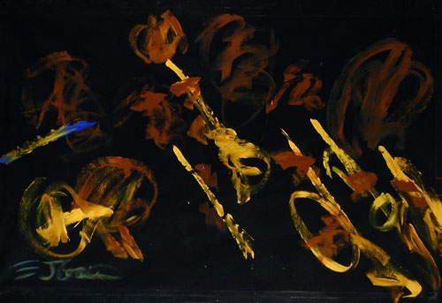
The Chico Smorgallees

Jazz Ensemble

- Perpetuating the Tradition of Big Band Jazz -

Performs Once a Month at:
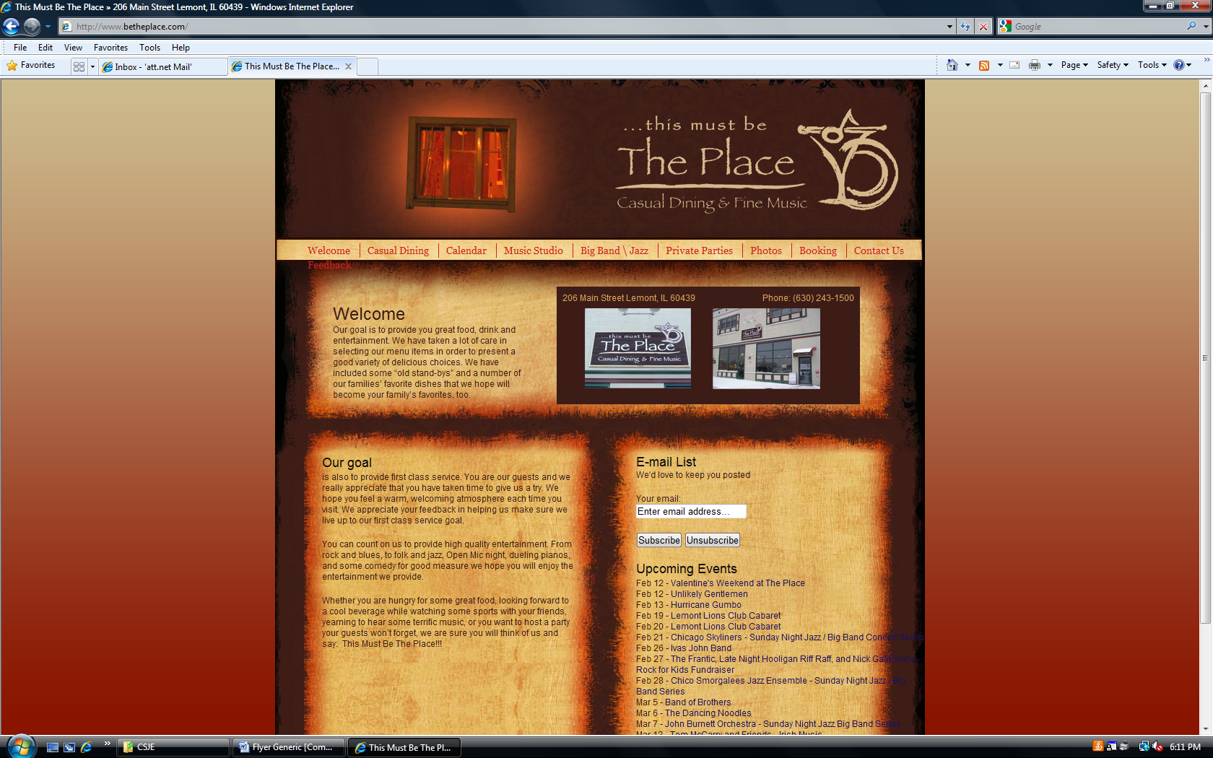

in downtown Lemont as part of their continuing Sunday Jazz Series. Check them out at:

www.BeThePlace.com
(630) 243-1500

